Kresge Final

**Steps for the Analysis:**

1. Pull Full Datasets from Attune
   * Pre and Post are saved in different folders
2. Run Folder(“Full Data”) through Kresge_auto_agg_to_excel.R
   * Argument can be changed at “summary_data <- XXX”
   * sum_up gives the 5numsum of all files
   * do_both(combine_variables(data)) does and hour average for all files
   * Update input folder name and output folder name as needed
3. Do_Both creates a .xlsx file where each location gets its own sheet
   1. sum_up does this as well
4. For use, run the do_both file through the mulitplesheets() function
   1. This will load the individual sheets to R

comp_plot(temp_long_subset, 74, "Temperture Comparison")

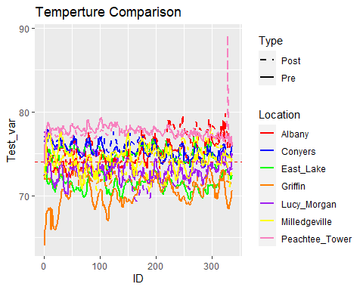

comp_plot(hum_long_subset, 70, "Humidity Comparison")

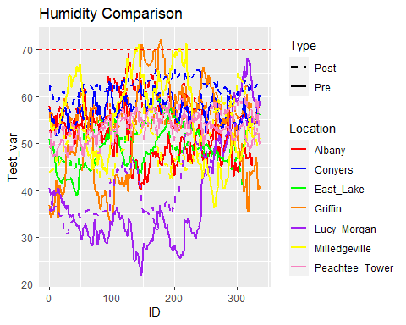

comp_plot(co2_long_subset, 2001, "Co2 Comparison")

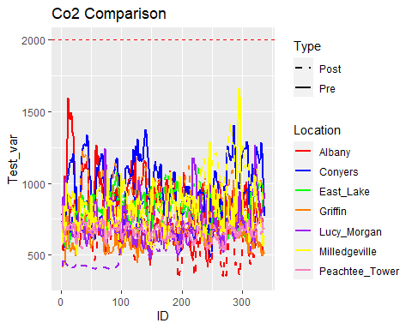

comp_plot(pm2.5_long_subset, 55.5, "Pm2.5 Comparison")

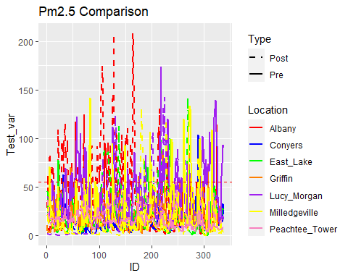

comp_plot(pm10_long_subset, 255, "Pm10 Comparison")

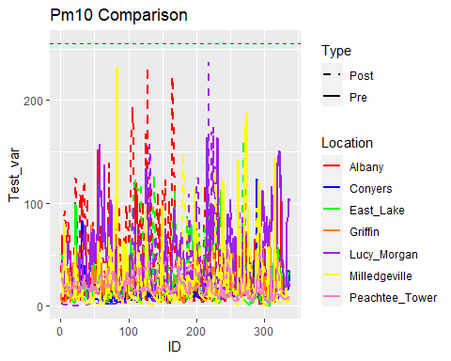

comp_plot(pm10_long_subset, 255, "Pm10 Comparison")

